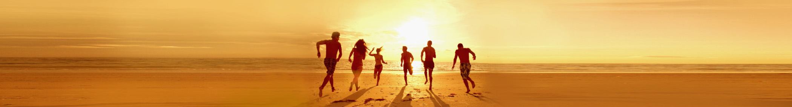

Vacation Packing List

|  |  |  |
| --- | --- | --- |
| Clothes |  | Toiletries |
| |  |  | | --- | --- | |  | Bathing suits! | |  | Workout wear | |  | Beach wear | |  | Day clothes | |  | Evening clothes | |  | Light jacket or sweater | |  | |  |  | | --- | --- | |  | Shampoo and conditioner | |  | Hair styling products | |  | Moisturizer | |  | Toothbrush, toothpaste, and floss | |  | Razor and shaving cream | |  | Perfume, cologne, or aftershave | |

|  |  |  |
| --- | --- | --- |
| Important Documents |  | Medical |
| |  |  | | --- | --- | |  | Passport | |  | Driver’s license | |  | Reservation confirmations | |  | Travel and event tickets | |  | Map of my destination | |  | Guidebook | |  | |  |  | | --- | --- | |  | Prescription medications | |  | Pain relievers | |  | Hand sanitizer | |  | Sunscreen | |  | Lip balm | |  | Bandages | |

|  |  |  |
| --- | --- | --- |
| Accessories |  | Electronics |
| |  |  | | --- | --- | |  | Belts | |  | Shoes | |  | Jewelry | |  | Beach bag | |  | Flip flops | |  | Hat | |  | |  |  | | --- | --- | |  | Tablet | |  | Smartphone | |  | Bluetooth headset | |  | MP3 player for sports | |  | Chargers for all devices | |  | Converter, if traveling internationally | |

# Note

To easily add more categories, do the following: 1. Click on any category name and then, on the Table Tools Layout tab, choose Select Table. 2. On the Home tab, choose Copy and then press Ctrl+End to go to the end of the document. 4. Press Enter and then, on the Home tab, choose Paste.